SQA Academy Course -
Preparing to Deliver an SQA Qualification and
Understanding a Unit Specification

Go to https://www.sqaacademy.org.uk/
If you are a new user, you will have to register and create a user account.
To create a user account, click on the arrow beside the log in details

On the next page, create your SQA Academy account.
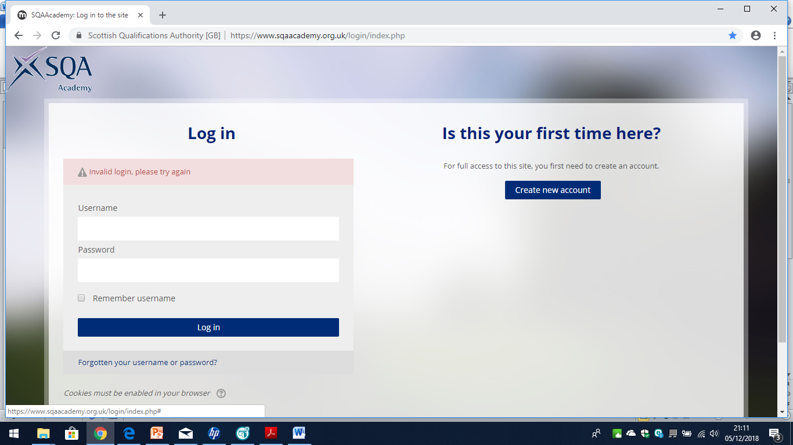
For future use of SQA Academy, start by entering your username and password in the top corner.
Select > Course categories > International > Support for new Centres > Click to enter this course
You will then have access to the course.

Select ‘Your Centre and Role’ to complete your information.
It is important that you complete this section.
The information will be used to tailor any further support your centre may find appropriate.
Select ‘Preparing to Deliver an SQA Qualification’. This will open a new window to start the course. Work through each section.

In Section 2 (Planning) of ‘Preparing to Deliver an SQA Qualification’, you will be asked to select the link to ‘Understanding a Unit Specification’. This will open a new window.

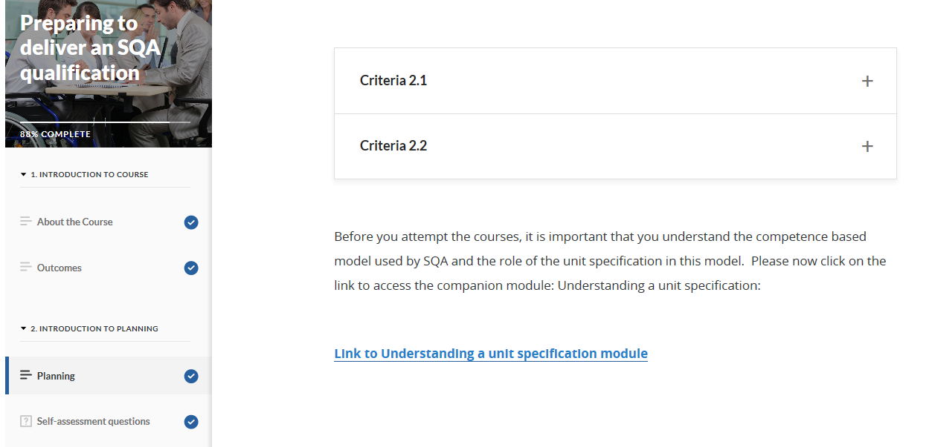

If the link does not open a new window, you can return to the Support for new Centres page, and access ‘Understanding a Unit Specification’ from there.

When you have completed this section, close the window and return to ‘Preparing to Deliver an SQA Qualification’.

Throughout the course, there are quizzes to check your understanding. Some quizzes will show you a score once completed.
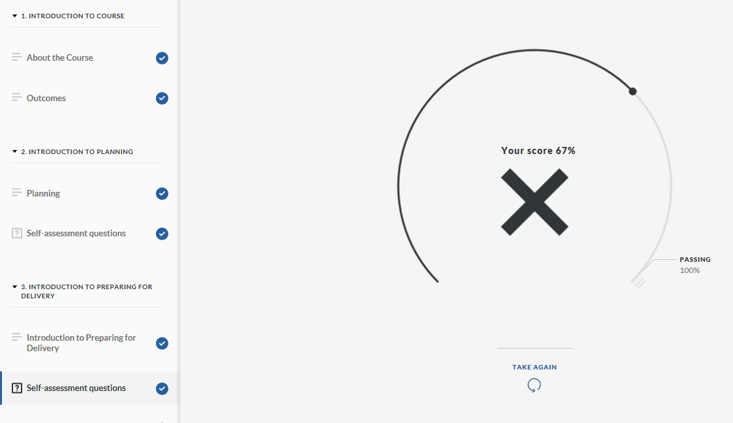
If you have any incorrect answers, you can try again.
Some quizzes in the course show you the correct answer.
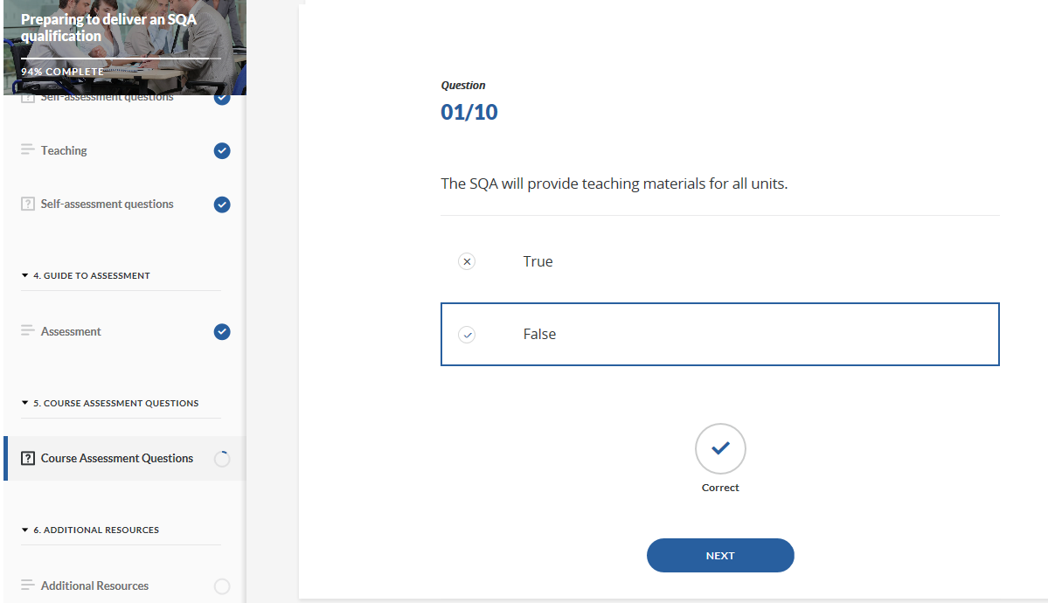
Remember: you can complete the course at your own pace. You can log out and return to the course at a time that suits you.
If you experience any problems with the website, please contact academy@sqa.org.uk

